Andy Beshear  Governor  Ray A. Perry  Secretary |  | Robert L. Astorino  Executive Director  Molly B. Cassady  General Counsel
Kentucky Real Estate Authority
Kentucky Real Estate Commission
Mayo-Underwood Building
500 Mero Street, 2NE09
Frankfort, Kentucky 40601
Phone: (502) 564-7760
https://krec.ky.gov

KENTUCKY REAL ESTATE COMMISSION
(KREC)

MEETING MINUTES
September 29, 2021
2:00 p.m.
KYR Annual Convention
Cincinnati Marriott at River Center, Covington Room Sections II & III
(10 West River Center Boulevard, Covington, Kentucky 41011)

Commission Members Present

Commissioner Chair, Lois Ann Disponett
Commissioner Larry Disney
Commissioner Steve Cline
Commissioner Raquel Carter
Commissioner James King

KREA Staff

Robert Laurence Astorino, Executive Director
Molly Cassady, General Counsel
John Hardesty, Former General Counsel, Director of Claims and Appeals
Hannah Carlin, Education and Licensing Coordinator
Brian Travis, Investigator
Angie Reynolds, Administrative Specialist III

Guests Present

Aaron Gregory
Al Blevins
Alice Carr
Angela Clark
Angi Cline
Barbara Flann
Barry Turner
Bonnie Byerly
Bree Snow
Brenda Loyal
Carter Martin Jr.
Charles Hinkley
Christopher Fox
Cindy Payne
Cindy Rice Grissom
Daryl Hyatt
Doug Meyers
Earleen Aula
Elizabeth Monarch
Hannah Porter
Helen Fardo
Janie Wilson
Jason Belly
Jason Gesso
Jim DeMaio (RASK)
Judie parks
Kathryn Vaugh
Kelly McGough
Kim Ohan
Kim Whalen
Kimberly Sickle
Lamont Breland
Laura Disney
Lester Sanders
Lil Cid
Linda Townsen
Lisa Presley
Lynda Fernandez
Maggie Harper
Marcie Estepp
Matt Commer
Matt Foden
Melissa Adams
Melissa Manley
Michard Constantine
Mitch Collins
Mike Mudd
Molly Matter
Nicole Knudtson
Norman Jones
Pamela Featherstone
Paula Barmore
Peggy Smith
Rhonda Richardson
Richard Wilson
Rip Petting
Robin Roseberry
Ron Bossant
Jeff Smith
Ronald Hughes
Ronald Sickle Sr.
Sandy Jewell
Shannon Collett
Sharon Billingsly
Shelly Sutton
Stacy Fry
Steve Stevens
Sue Ann Collins
Teri Jim
Tiffany Carlson
Tulla Williams
Veronica Dickerson

Call to Order and Guest Welcome

The Kentucky Real Estate Commission meeting was called to order by Commission Chair, Lois Ann Disponett, at 2:00 p.m. on September 29, 2021 at the at KYR Convention, held at the Cincinnati Marriott at River Center, Covington Room Sections II & III located at 10 West River Center Boulevard, Covington, Kentucky 41011. At this time staff introduced themselves to the gallery. Roll call was taken, and a quorum was present. Guests in attendance were welcomed and introductions of guests, staff, and Commissioners were made.
Approval of Meeting Minutes
Commissioner Cline made a motion to approve the August 19, 2021, Meeting Minutes. Commissioner Disney seconded the motion. With all in favor, the motion carried.

Education and Licensing Report

Ms. Hannah Carlin presented to the Commission the following:

- PSI Testing Statistics
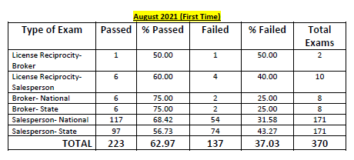
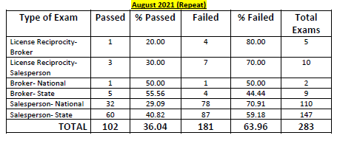
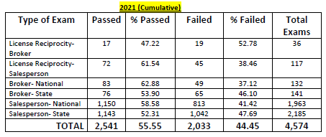

- Licensing Statistics
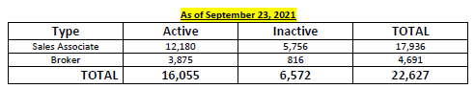
Licensees cancelled in August 2021: 17 (3 brokers, 14 sales associates)
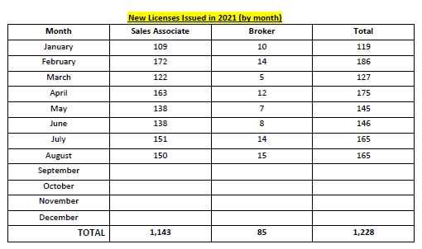
The September 2021 Continuing Education Applications were reviewed for compliance with 201 KAR 11:170 and recommended to the Commission for approval by Hannah Carlin.
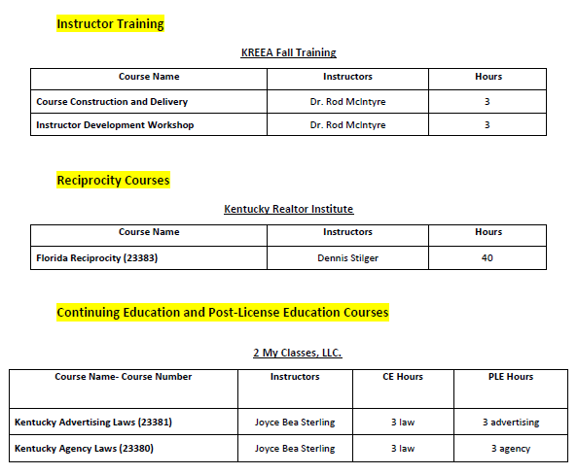
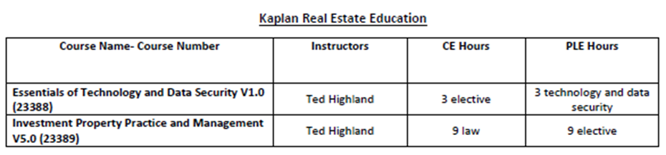
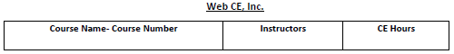
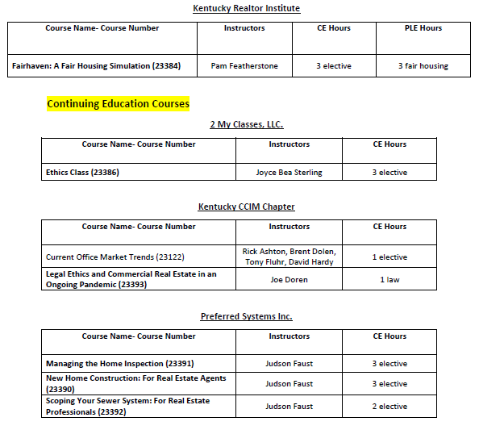
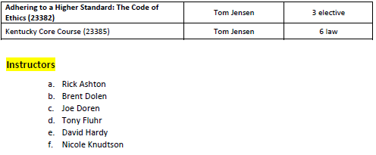

Commissioner Cline made a motion to approve the list of applications. Commissioner King seconded the motion. Commissioner Disney abstained from the discussion and the vote. Remaining all in favor, motion carried.

Ms. Carlin presented the September 2021 licensing requests:
- 175762: Commissioner Cline made the motion to deny. Commissioner Disney 2nd. Having all in favor, motion carried.
- 186033: Commissioner Disney made the motion to deny. Commissioner Cline 2nd. Having all in favor, motion carried.
- 272798: The individual is licensed in Indiana and wants to obtain a sales associate license in Kentucky. She completed the 96-hour pre-license course, submitted her fingerprints for a background check, and passed the licensing exam. Due to confirmed miscommunications from PSI to the individual, she took the Kentucky broker exam instead of the sales associate exam. The individual is requesting the Commission grant her a sales associate license based on the exam results of her Kentucky broker exam. The Commission determined the broker exam is more difficult than the sales associate exam, and it meets and exceeds the requirements of the sale associate’s exam, including all law requirements. Due to the miscommunication by PSI that led to this issue and because passage of the broker exam evidences the same or greater competencies in real estate, the Commission is inclined to make a one-time exception in this circumstance.
When the licensee is entered into the DPL system, she will only be given credit as if it were the normal sales associate’s exam. In two years, if the licensee decides to take her brokers exam she would be required to take it again.
Commissioner Disney made the motion to approve. Commissioner Cline 2nd. Having all in favor, motion carried.

Ms. Carlin updated the Commission concerning the passing of House Joint Resolution 1, which extends the State of Emergency until January 15, 2022. The deadline for 2020 and 2021 education will be thirty (30) after the end of the State of Emergency, February 14, 2021. This is also the deadline for payment of E&O processing fees. If you have not completed your education and paid your E&O processing fees by February 14, 2021, you will be cancelled.
Changes to the brokers education will take effect March 1st, 2022. Anyone who wants to get their broker’s license before these changes take effect will need to acquire the requisite sales associate hours, complete their pre-licensing broker education, pass the broker’s exam, and submit their background check and application on or before March 1, 2022. Staff will be posting the information on our website, including any updates to the state of emergency, and sending out reminder emails. We want to ensure that everyone is aware that we now have definite deadlines.
It is imperative that everyone meet their requirements on or before the February 14, 2021 deadline because renewals will open up on February 15, 2021. Staff will be very busy and asks for your patience if you need assistance during this time.

Executive Director Comments
Director Astorino made welcoming comments and thanked everyone present for attending the meeting.
He advised that the Public Protection Cabinet has a new Secretary, Ray Perry. Secretary Perry previously served as the Deputy Secretary under former Secretary Harvey. Secretary Perry has designated DJ Wasson as his Chief of Staff. The Director has had very positive experiences working with the new administration thus far. It is tradition for the Kentucky REALTORS© to meet with an incoming Secretary and this meeting is scheduled to take place on October 7, 2021.
KREA has a new General Counsel, Molly Cassady. Former General Counsel, John Hardesty, has been appointed as the Executive Director of the Department of Claims and Appeals. KREA has also been assigned a legal intern from the University of Kentucky Law School, Marcus Lee.
The Cabinet has also appointed a new Deputy General Counsel, Betsy Stone. The Director recently met with Ms. Stone to discuss KREA’s complaint docket and the need for additional legal resources. Ms. Stone offered the part-time assistance of a second legal intern and the Director is hopeful that we will receive additional help from the Secretary’s Office.
Commission staff are working with the Finance Cabinet to obtain a new contract for the errors and omissions group insurance policy. Staff hopes to obtain a contract for a policy that coincides with the biennial license renewal cycle. Director Astorino will continue to provide updates on this issue as they become available.
Director Astorino conducted a phone satisfaction survey in which staff received an overall approval rating of 95%. He is pleased with these results and commended Commission staff for their efforts.
Committee Reports
Education Committee
The Education Committee did not meet this month.
Diversity, Equity, & Inclusion Subcommittee
The Diversity, Equity, & Inclusion Committee did not meet this month.
Applicant Review Committee
The Applicant Review Committee did not meet this month.
Complaint Review Committee

The Complaint Review Committee did not meet this month.
Public Comment
Chairperson Disponett opened the floor for public comments.
Rhonda Richardson asked for clarification regarding the approval process for Zoom courses after the State of Emergency ends. Ms. Carlin advised that education providers will be required to adhere to the regulation regarding distance education requirements.
Jeff Smith asked if the decision of removing the word ‘unknown’ from the Property disclosure form was final. Director Hardesty replied that the Commission made a formal decision to remove that language from the form and amend several other agency disclosure forms. The amendments will be filed with the Legislative Research Committee at which time the Commission will accept written and oral comments and will hold a formal hearing regarding the changes.
Legal Report
Director Hardesty stated that while this would be his last legal report, he will continue to work with the Commission and the other boards within the Authority to ensure the transition is seamless.
He also thanked Brian Travis and Angie Reynolds for all their hard work and assistance they provided while he was in the role of General Counsel.

Docket Update
Director Hardesty commented on the increase of complaints the Commission has received in recent months. He suggested this could be due in part to the active real estate market.
The legal staff are preparing for several upcoming hearings. One of which includes twelve (12) separate complaints.
Lastly, Director Hardesty gave a brief overview of the administrative regulation promulgation process regarding the proposed amendments to the forms incorporated in 201 KAR 11:121. He assured attendees that everyone will have an opportunity to make public comments.
Chairperson Disponett thanked Director Hardesty. Though she is excited to work with newly appointed General Counsel, Molly Cassady, Director Hardesty will be deeply missed.
New Business
Illinois Agreement
Director Hardesty gave an update on the ongoing negotiations with the Illinois Real Estate Commission regarding a potential reciprocity agreement. There is some disagreement between the Commission staff and representatives in Illinois regarding the disclosure of disciplinary actions taken against a licensee. All of the Commission’s current reciprocity agreements require the reciprocal state to notify the Commission of all pending or final disciplinary action taken against a licensee. The representatives in Illinois have issues with disclosing pending disciplinary action. The Commission discussed the issue at length.Commissioner Disney made the motion to instruct General Counsel to continue insisting the reciprocal agreement contains language that includes the disclosure of final and pending case information. Commissioner Cline seconded the motion. Having all in favor, the motion carried.
Approval Per Diem
- Commissioner Cline made a motion to approve the per diem and travel expenses for the September 29, 2021, KREC Regular meeting. Commissioner King 2nd the motion. Having all in favor, the motion carried.

Meeting Adjournment
The next KREC meeting will be October 21, 2021, at 9:00 a.m. for the regular meeting. Watch for a zoom link.
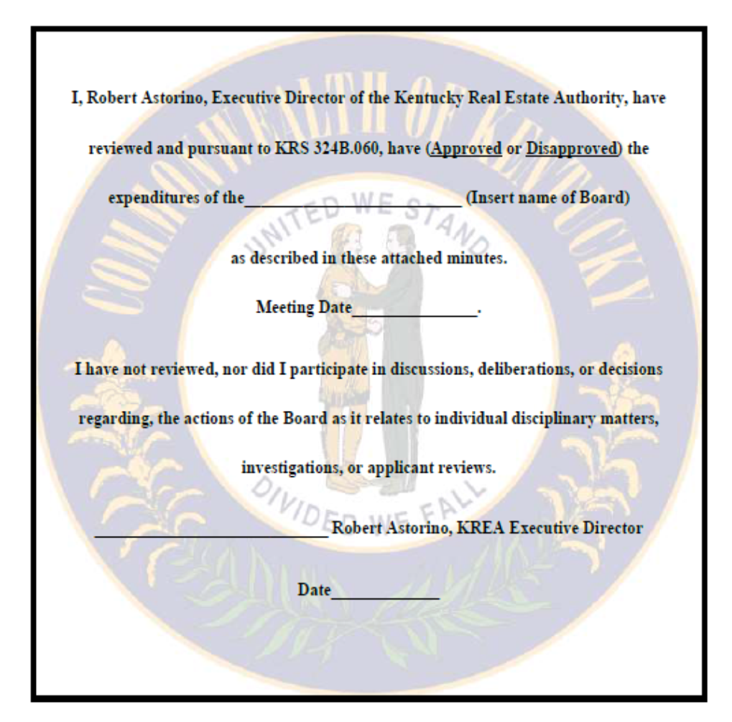
Commissioner Cline made a motion to adjourn the meeting. Commissioner King seconded. Meeting adjourned at 2:57 p.m.
Kentucky Real Estate Commission
September 29, 2021
September 29, 2021

